

AWS WEBINAR ASSIGNMENT

Face Detection Application



March 30, 2020

CHINNARAJA KARTHIKEYAN A M

3rd Year Mechanical Engineering, Sri Venkateswara College of Engineering, Sriperumbudur

**I) AWS:**

1)AWS Login screen with username:

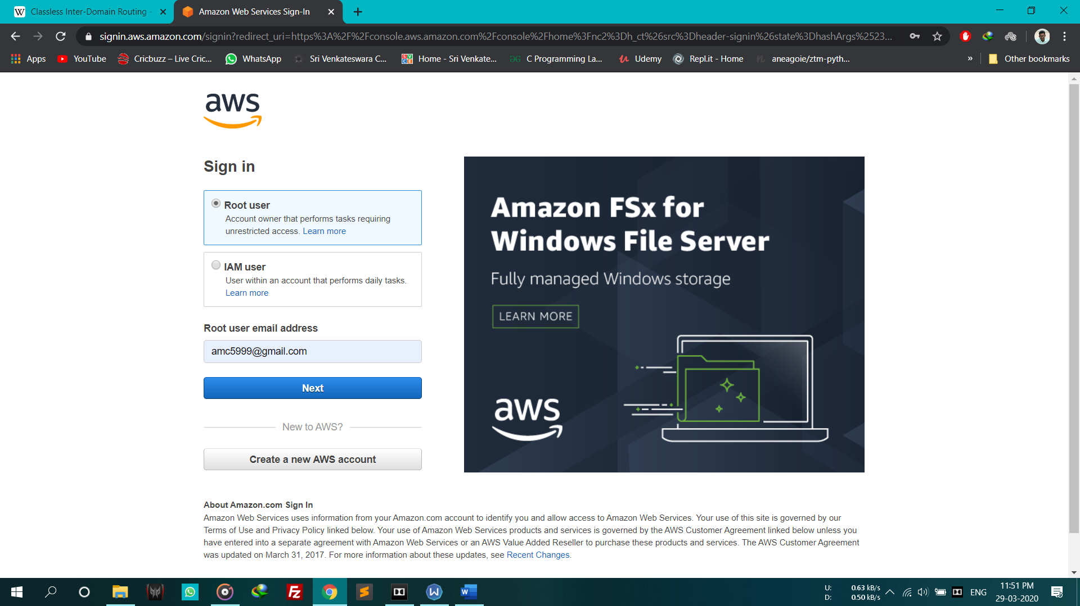

2)EC2 Dashboard: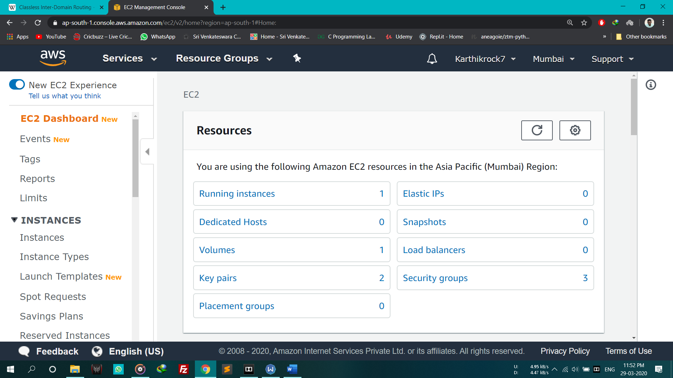

3)S3 Dashboard: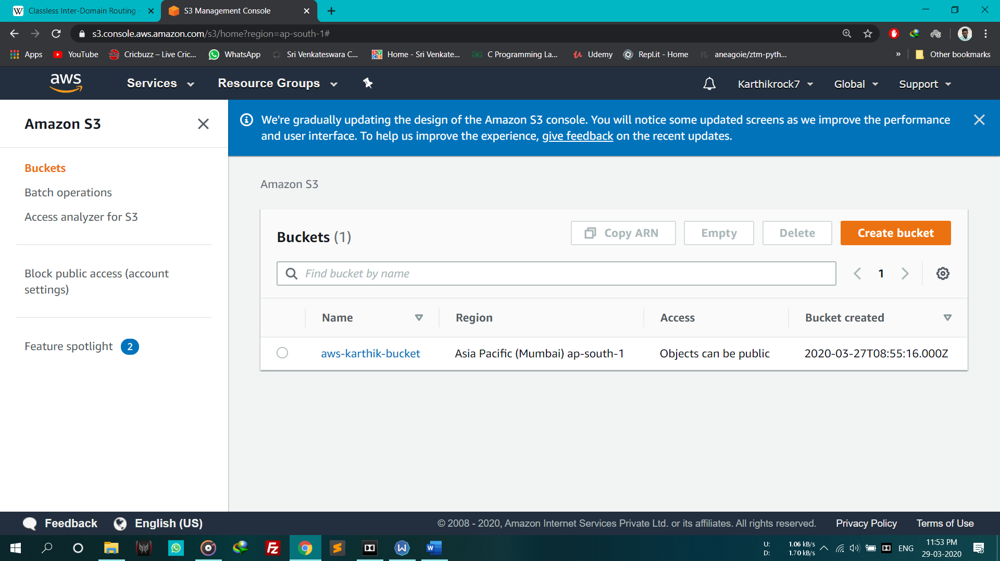4) Rekognition Dashboard: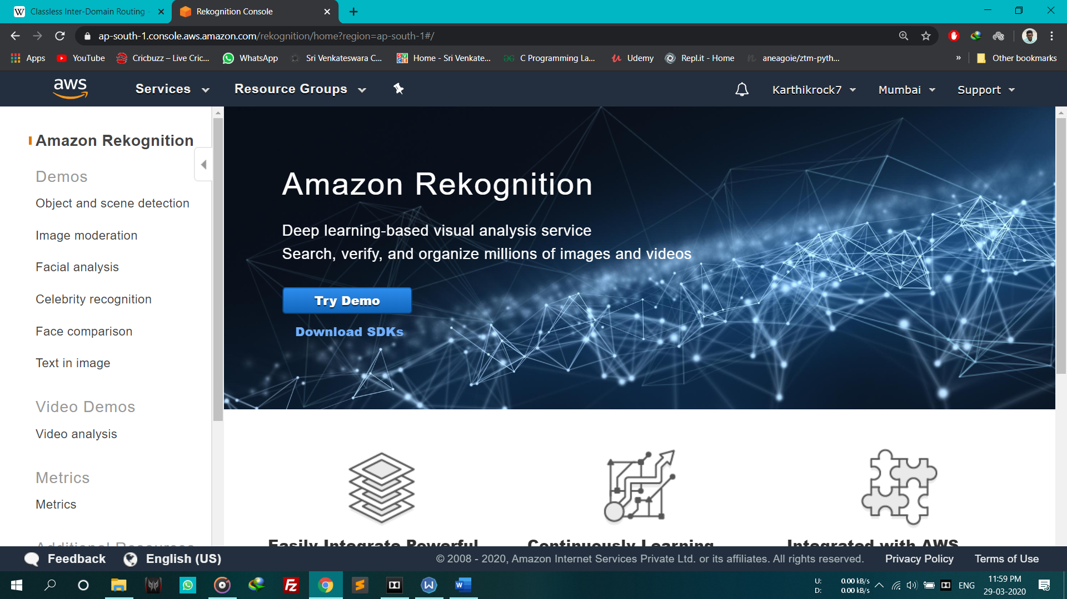

**II) EC2:**

1)Choosing an AMI: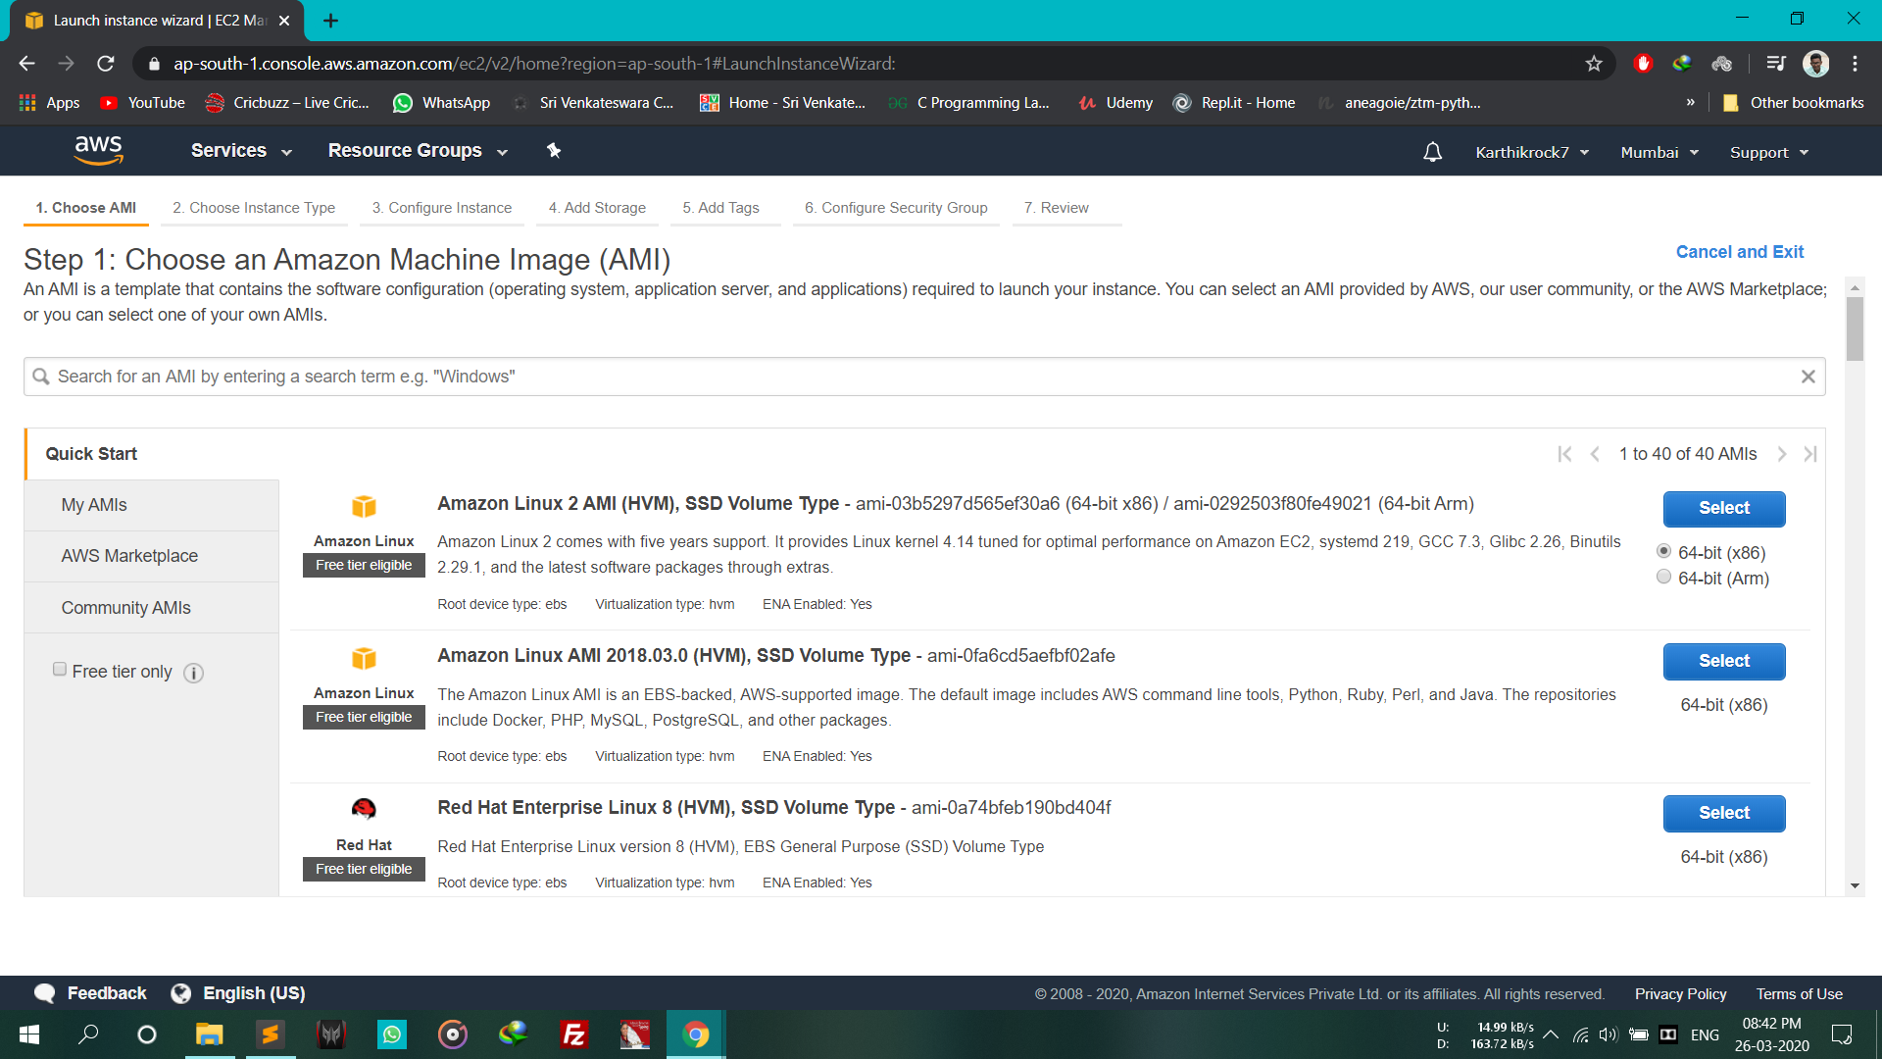2) Choosing an Instance type: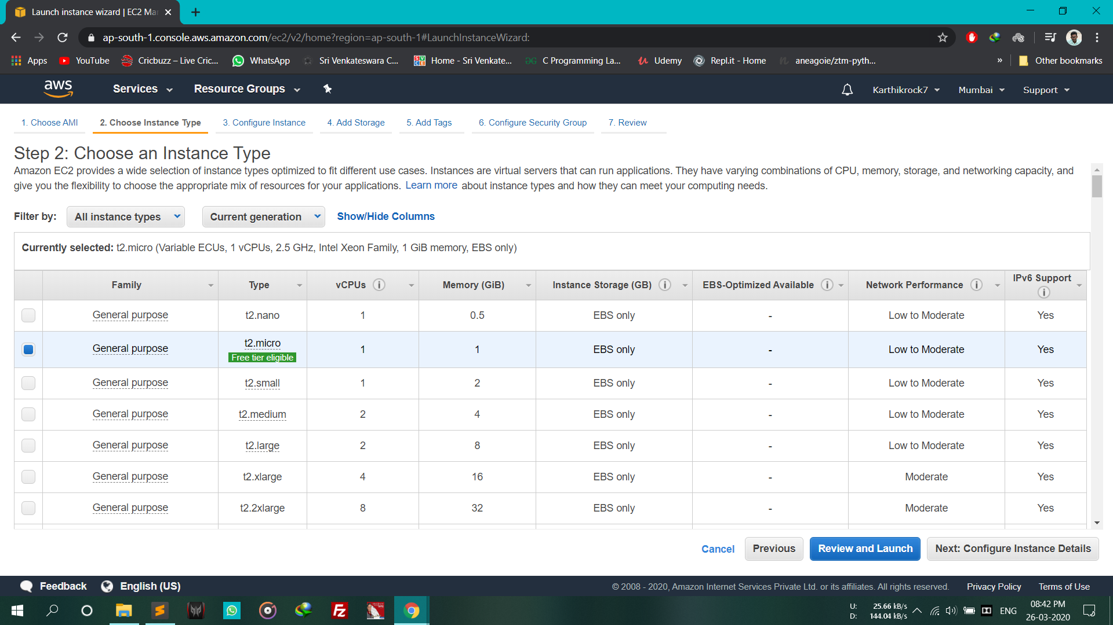

3) Adding Storage: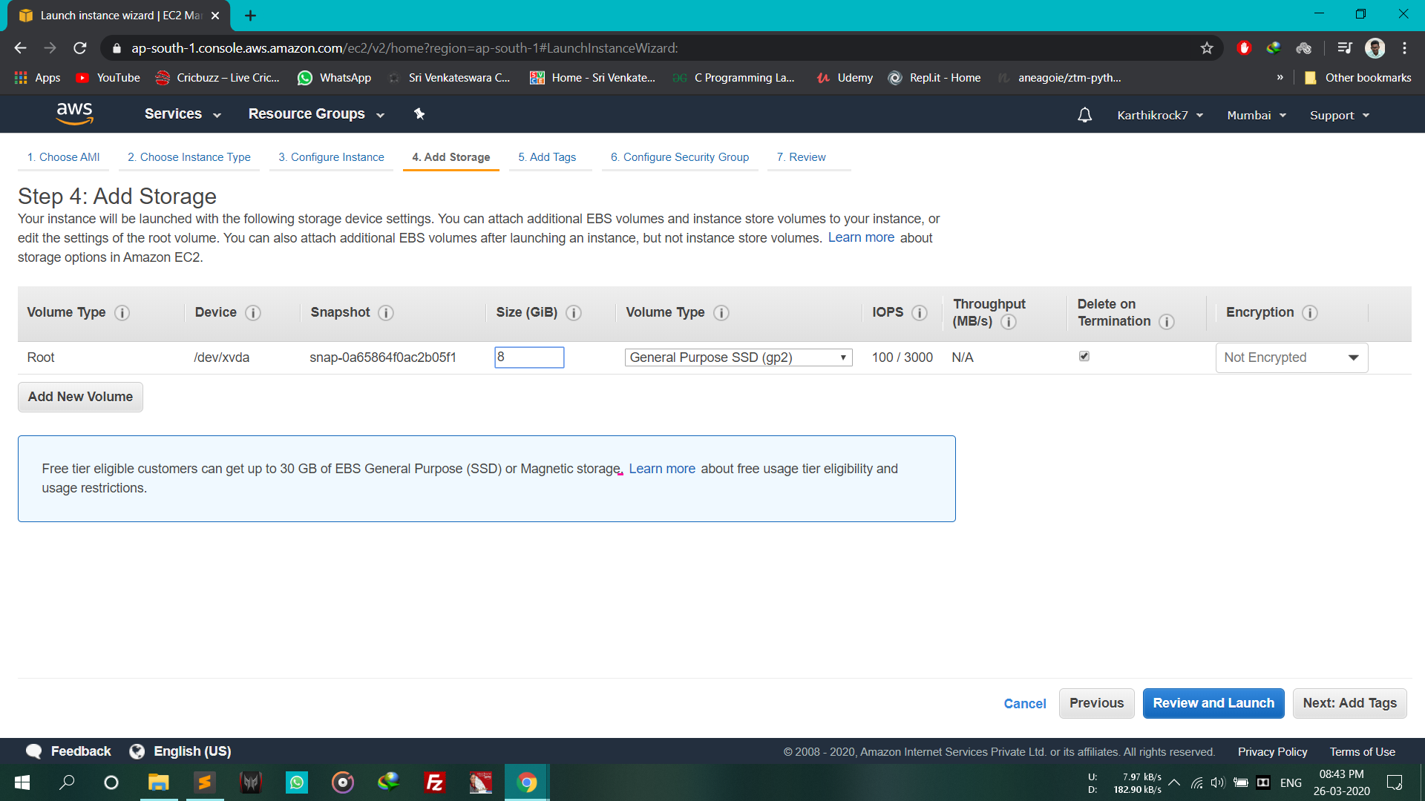

4)Configuring Security Group: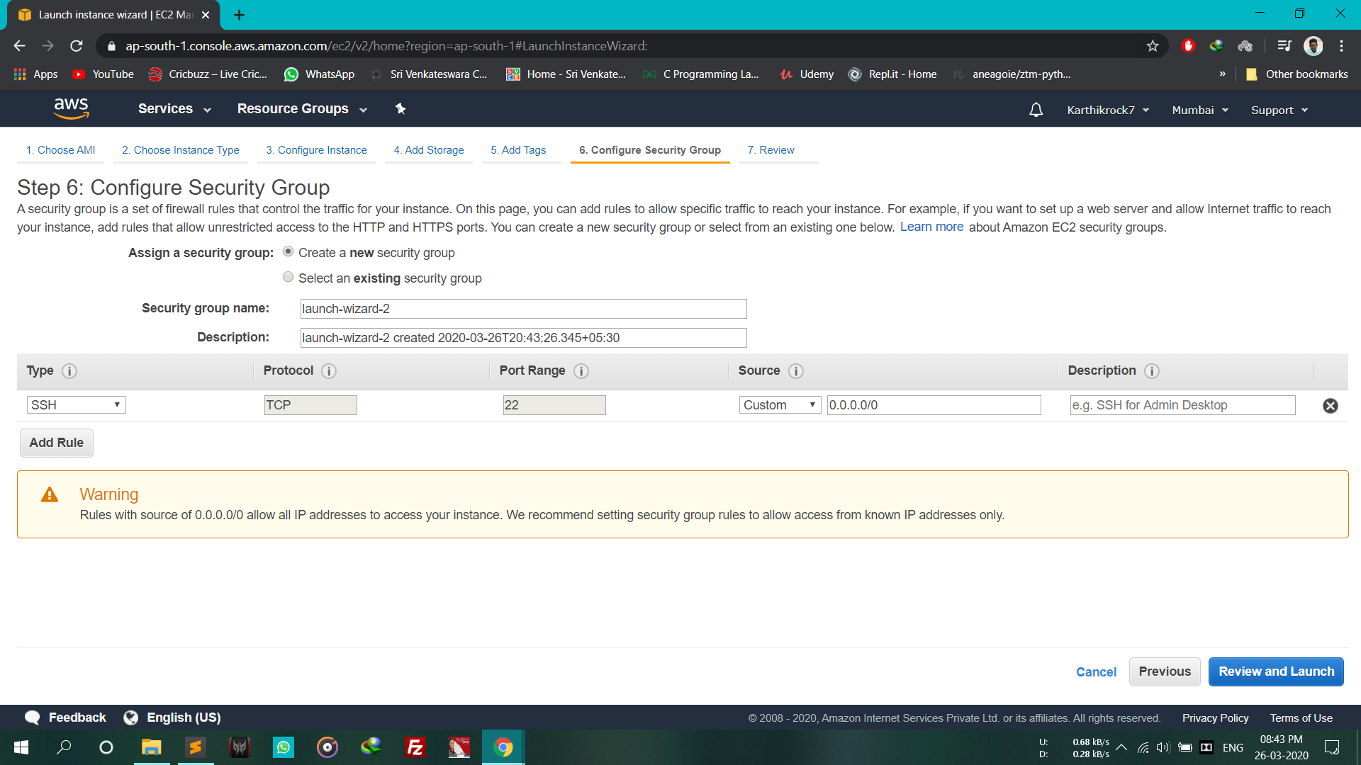

5)Key Pair Download: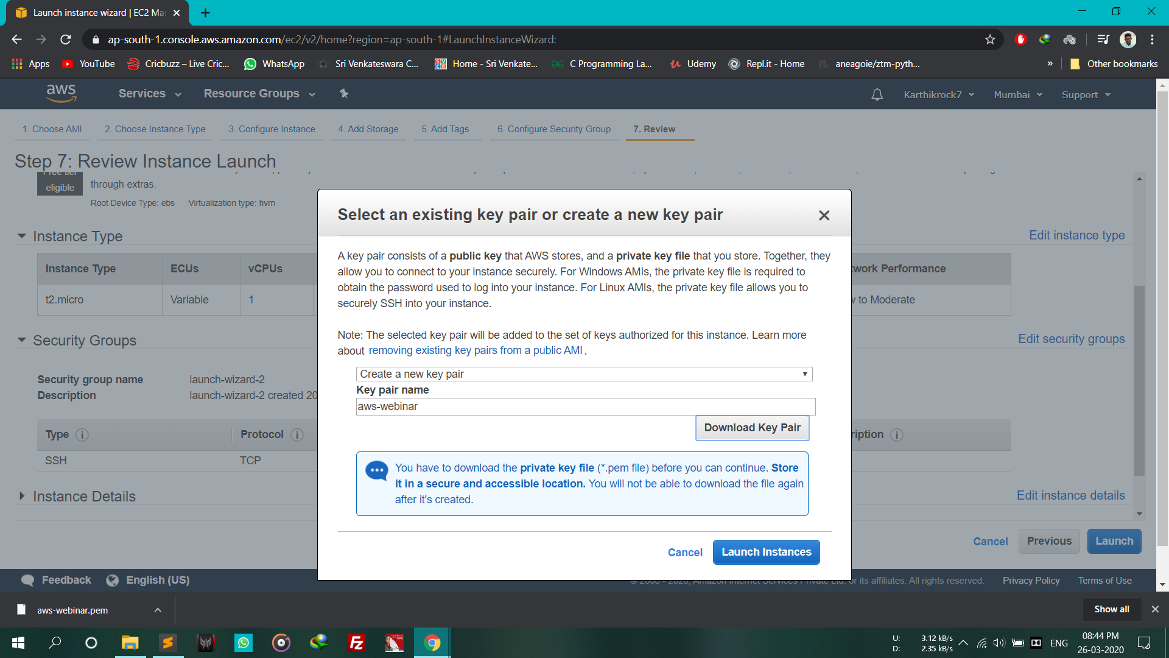

6) PuTTYgen conversion from .pem to .ppk file: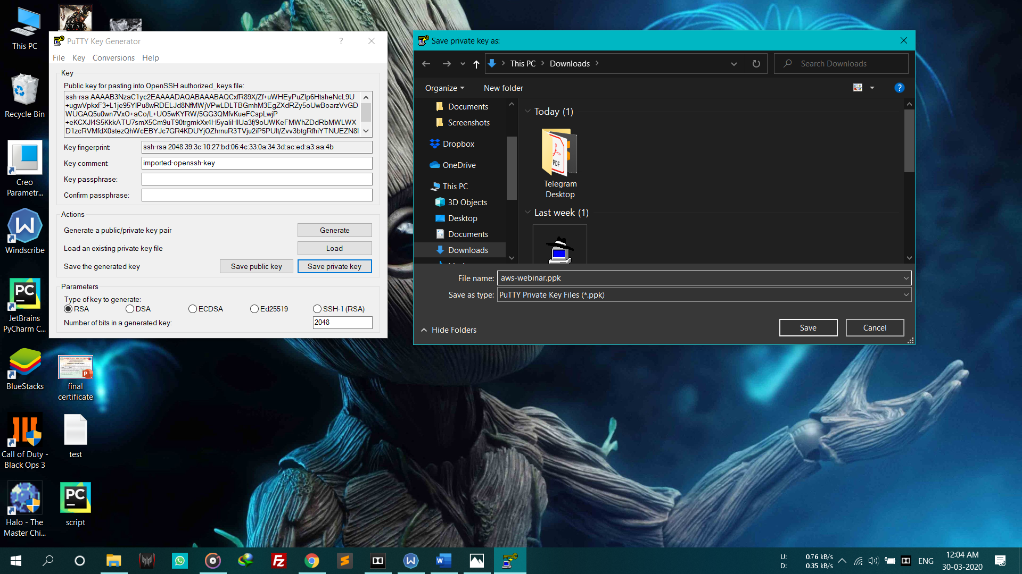

7) Logged in EC2 Blackscreen:

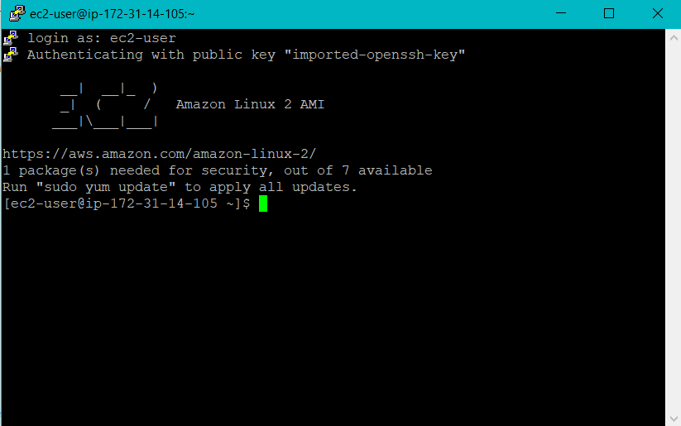

**III) S3:**

1) Creating a bucket: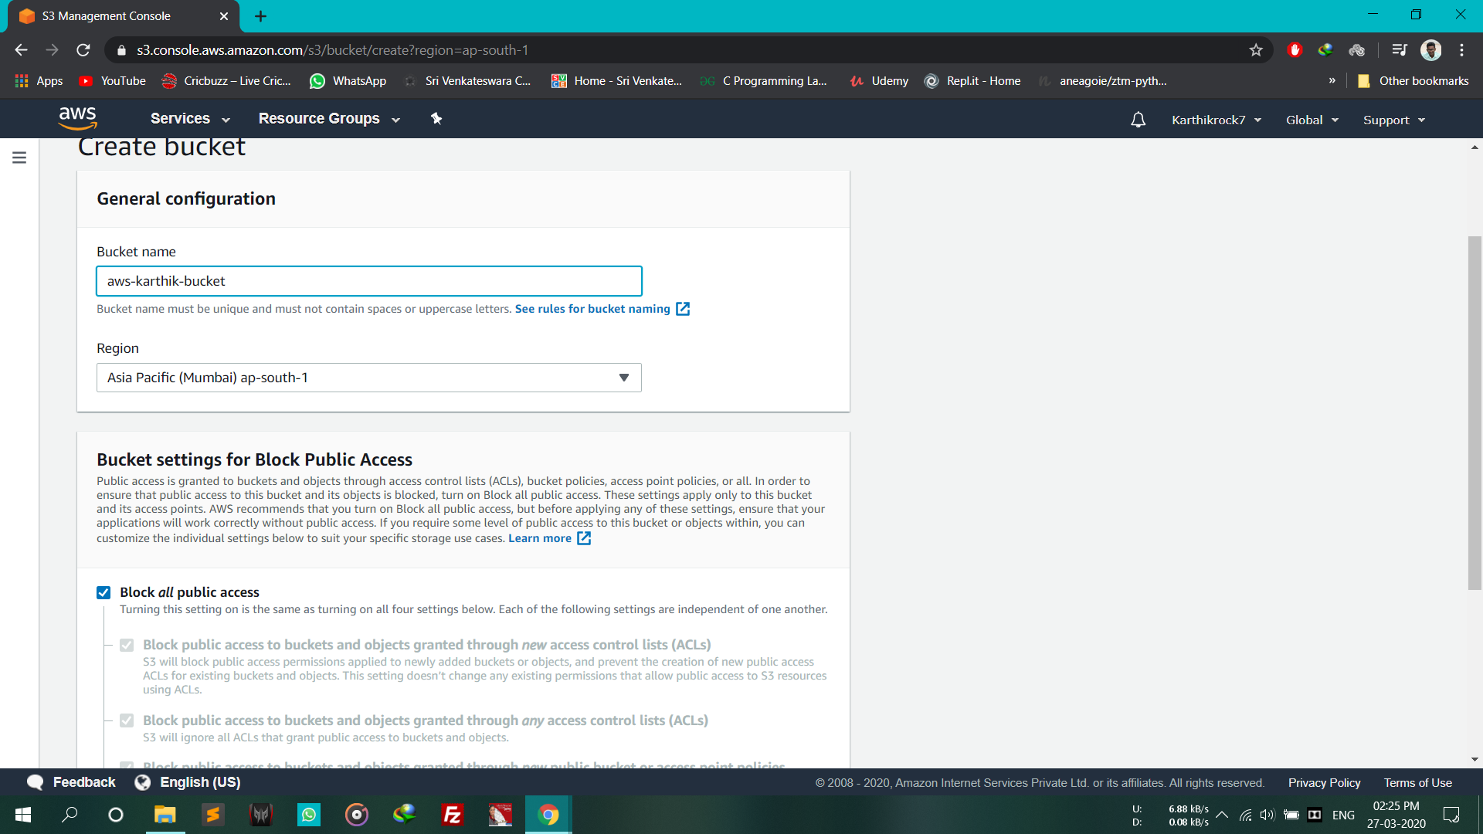

2)Uploading an object: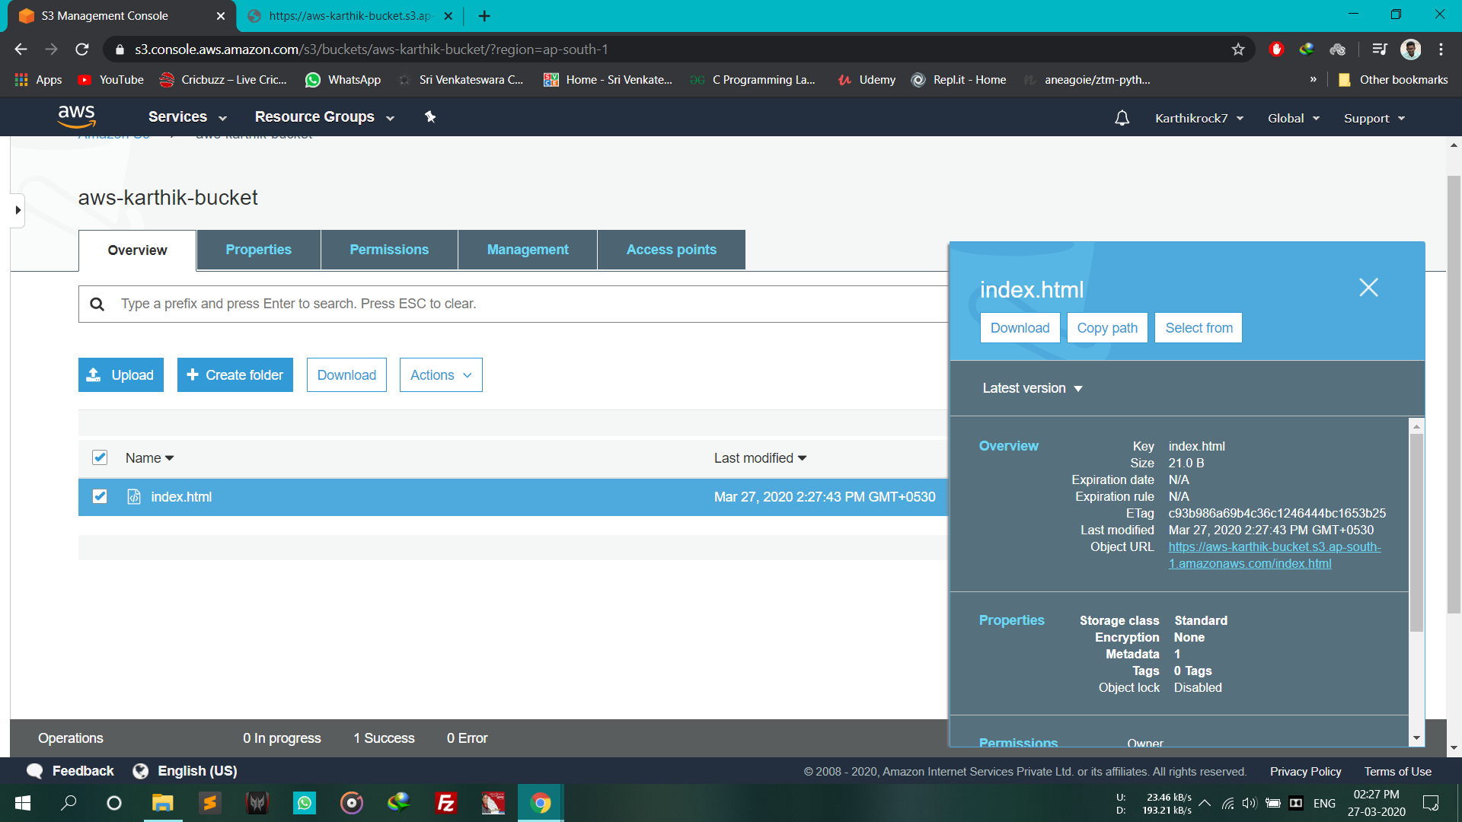

3)Enabling Static Webhosting: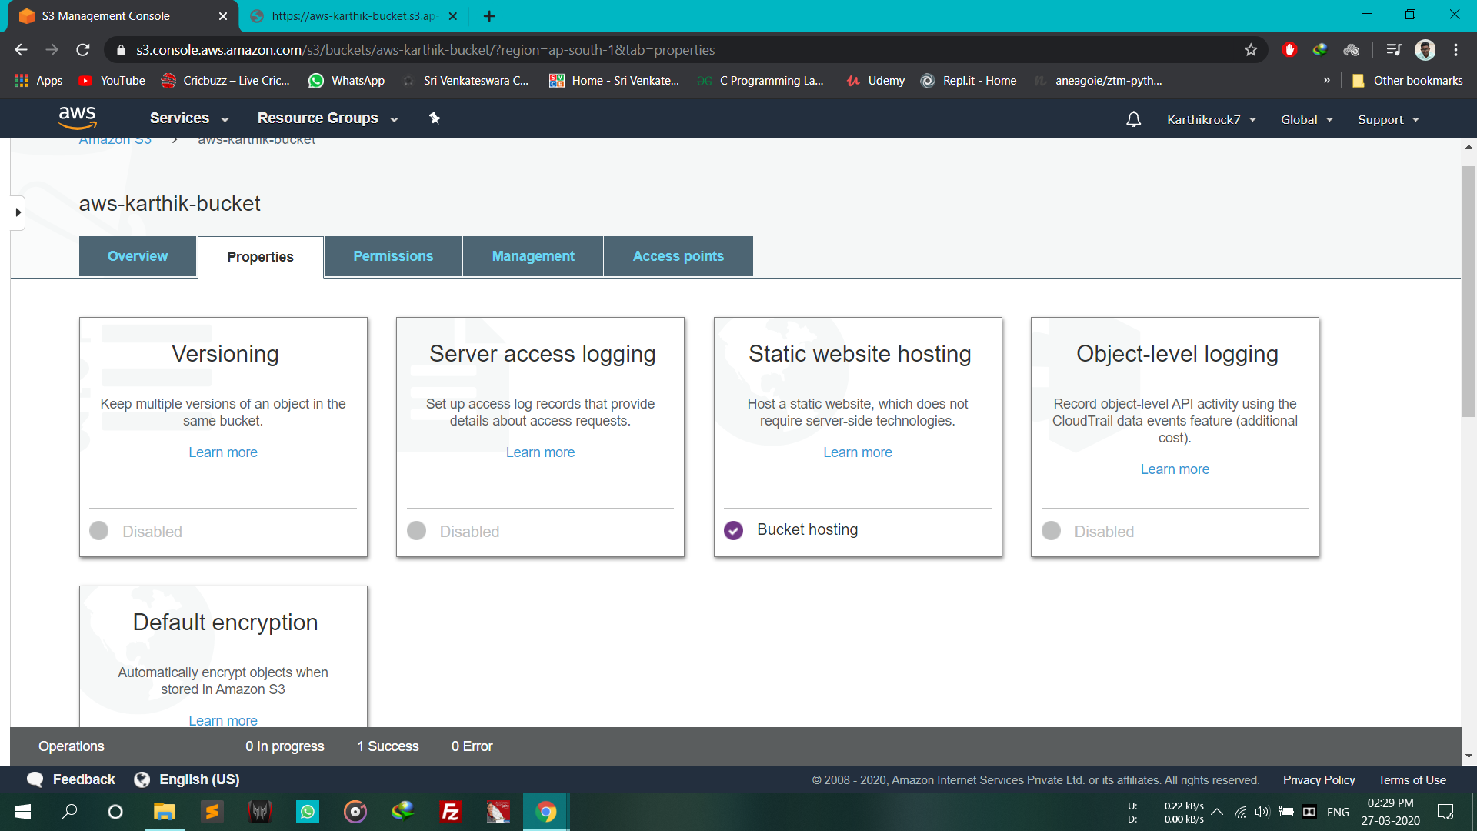

4) Making object Public: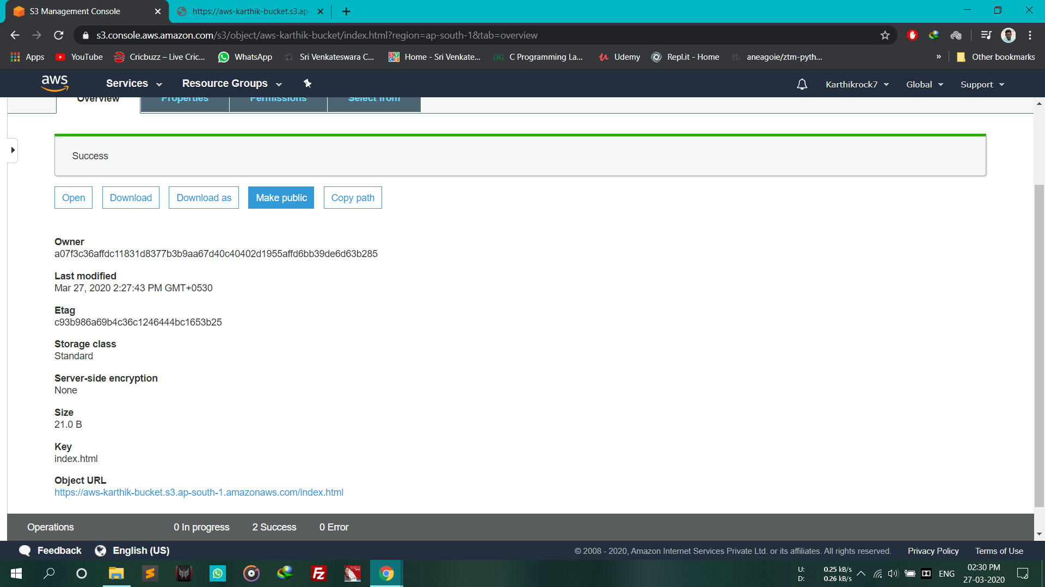

5) Checking S3 link on browser: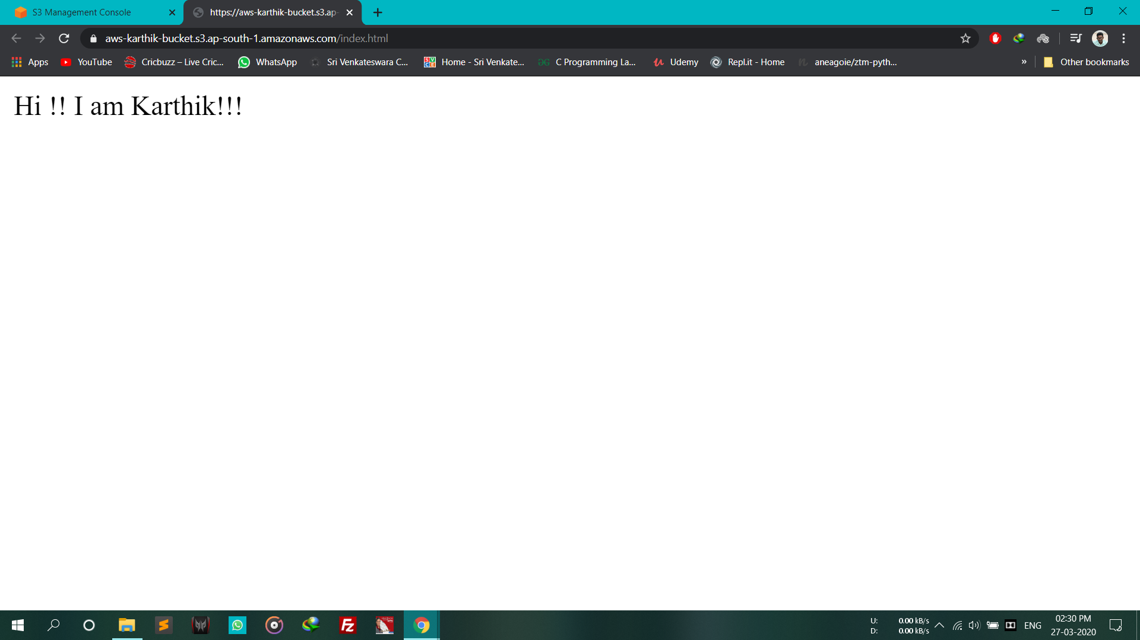

**IV) Rekognition:**

1) Face analysis: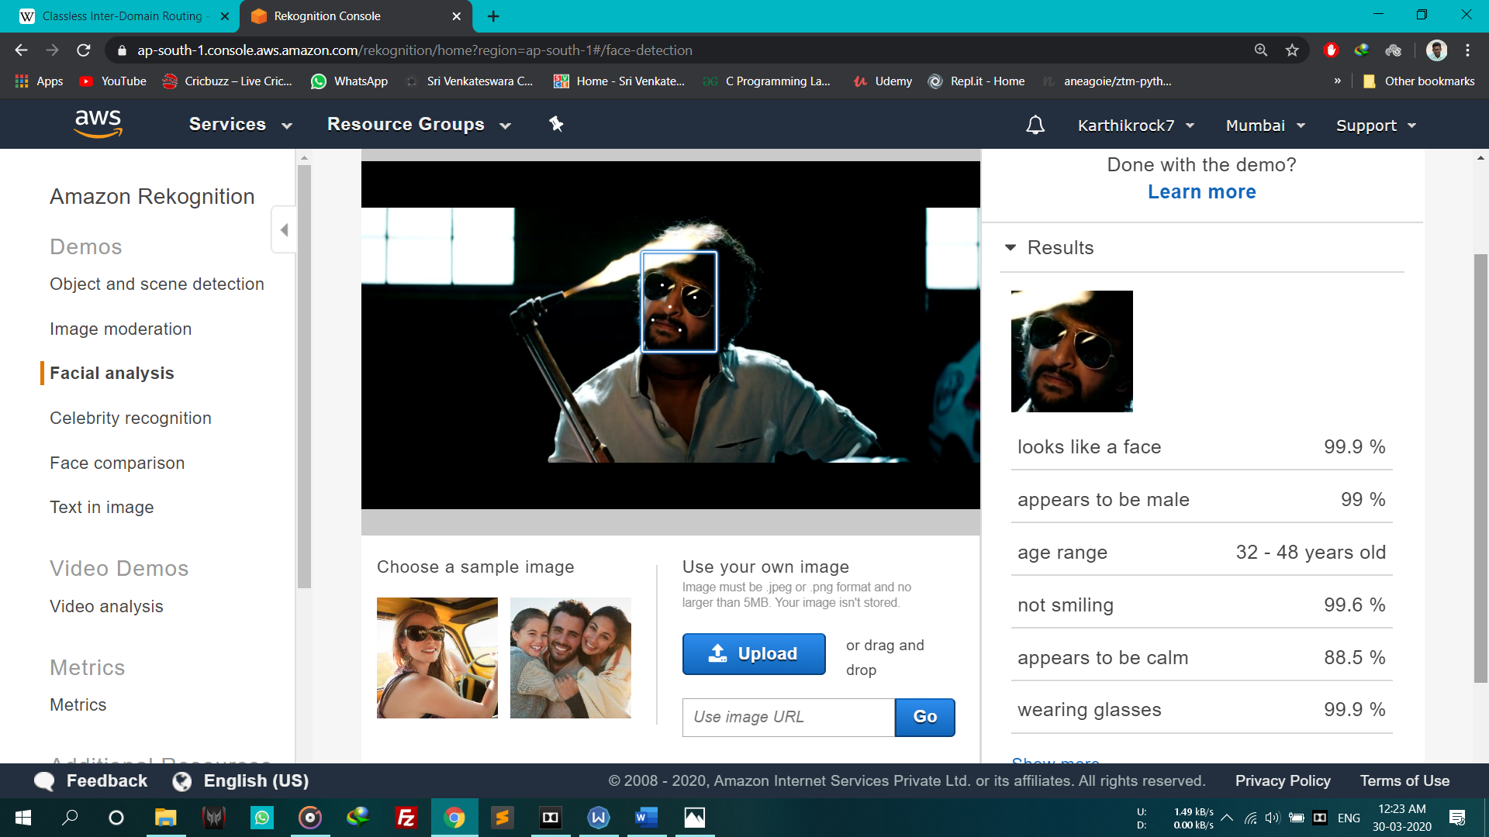

2) Celebrity Recognition: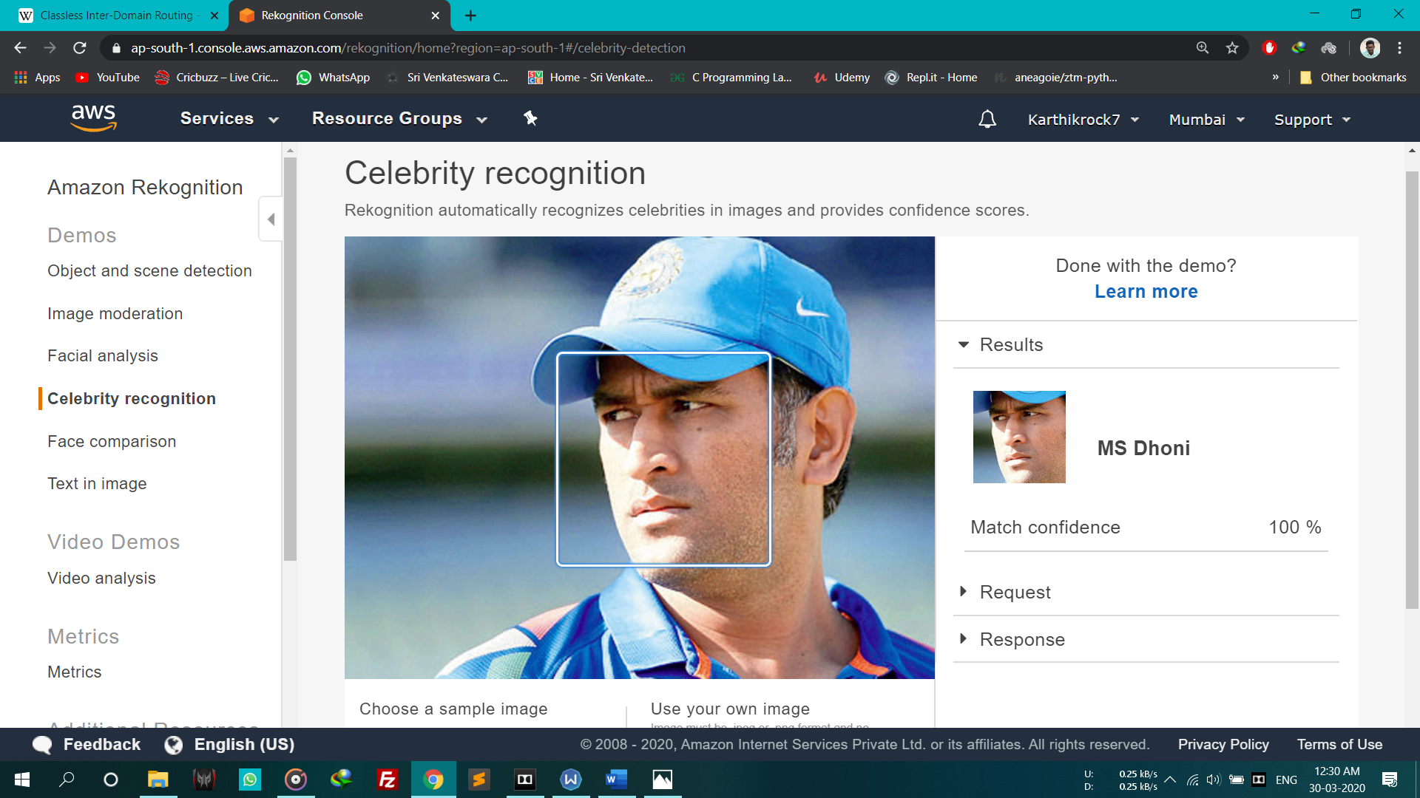

3) Face Comparison: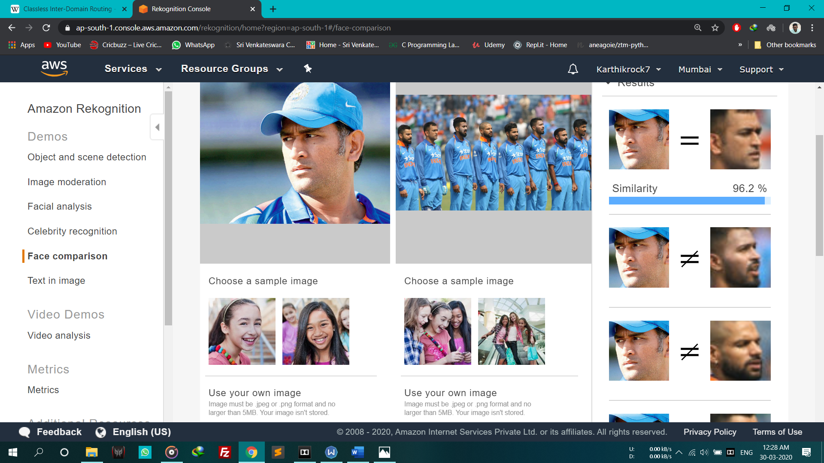

4) Text in Image: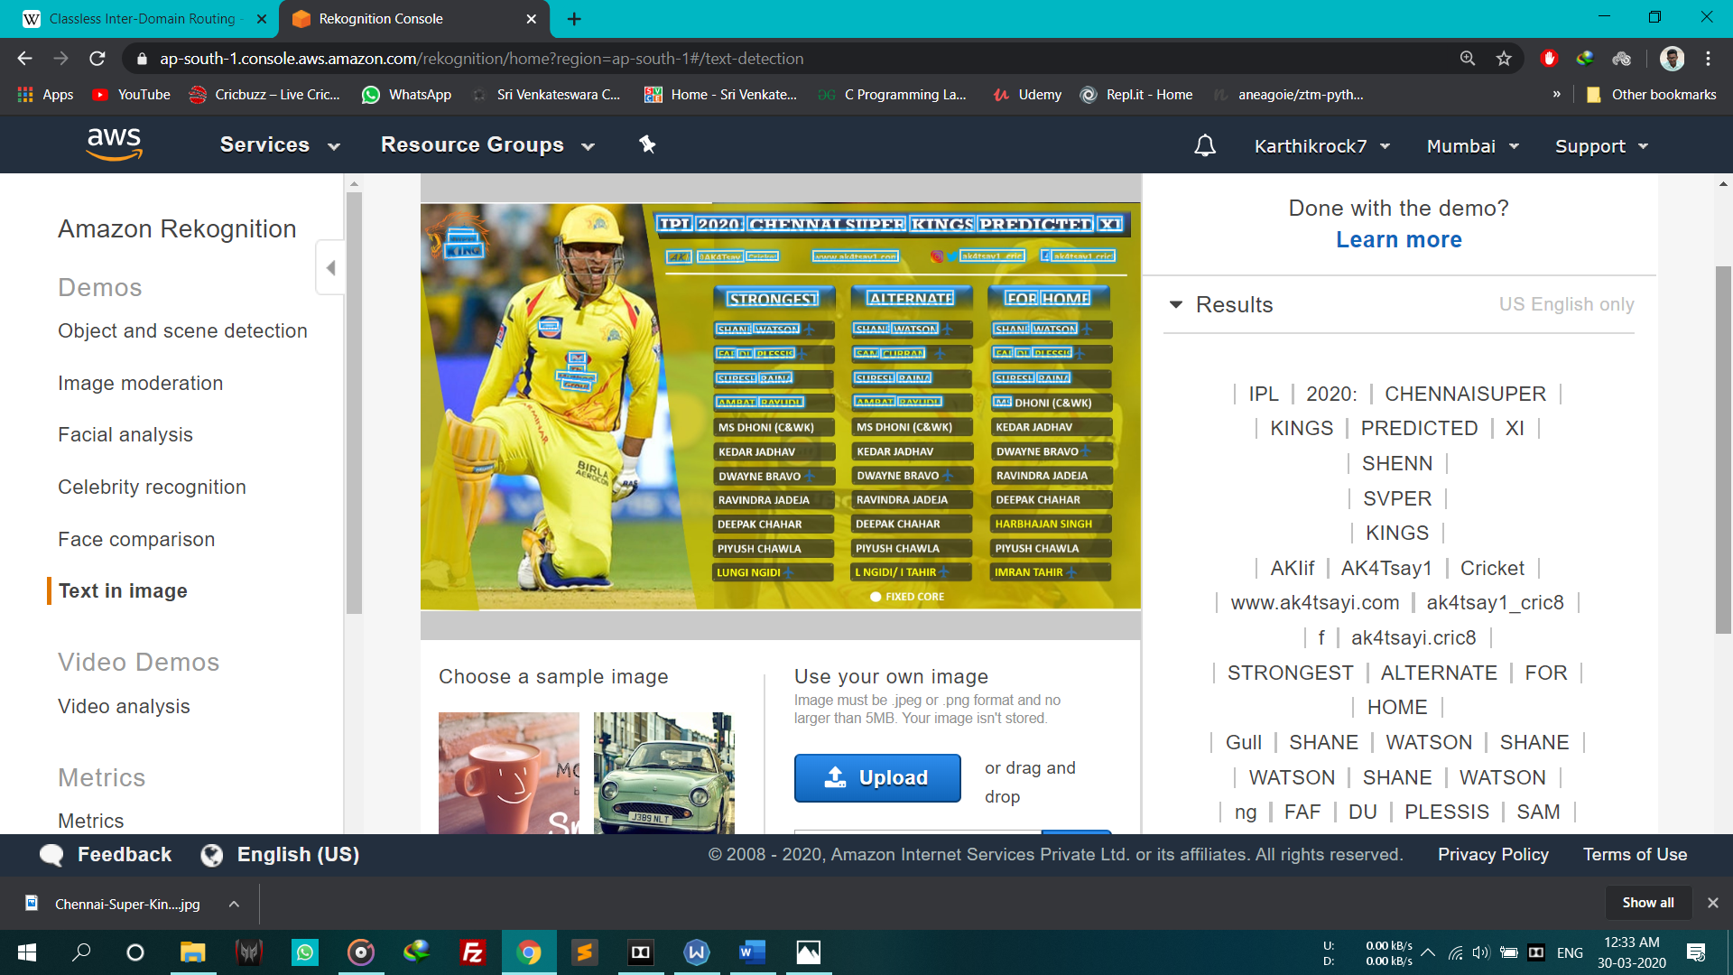

**V) EC2 & S3:**

1) Installing aws-sdk: 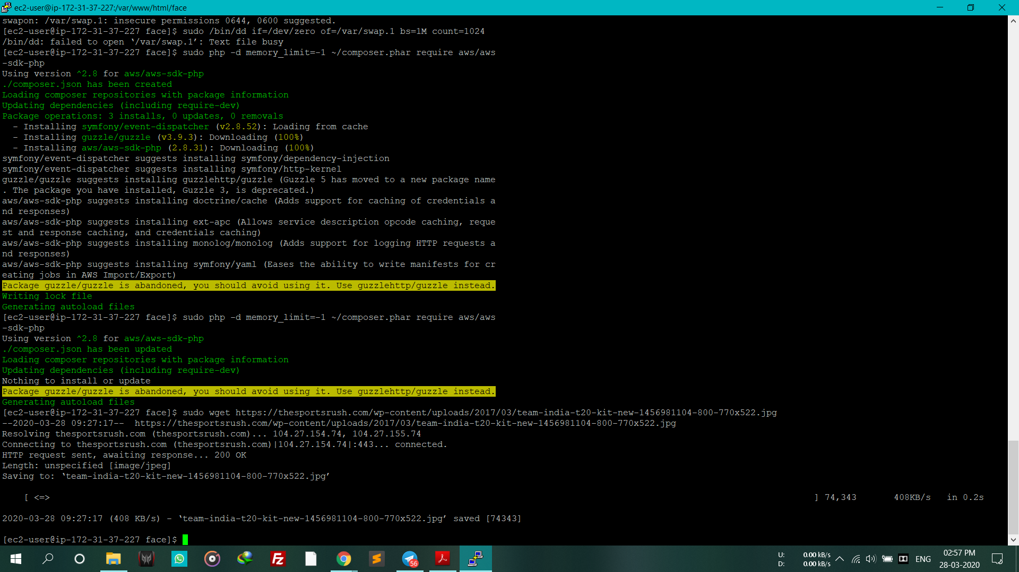

2) Installing php: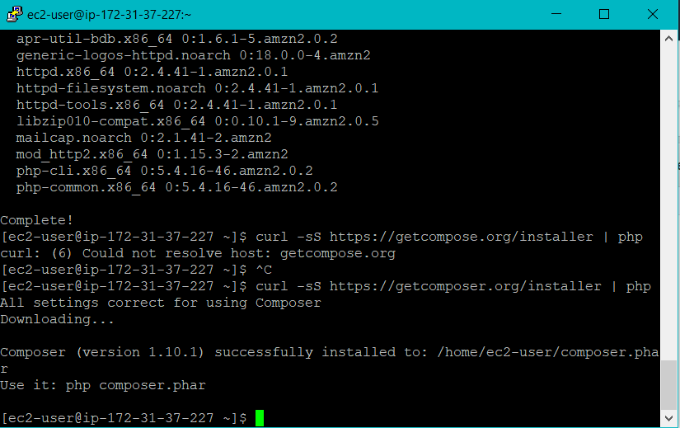

3)Code inside index.php: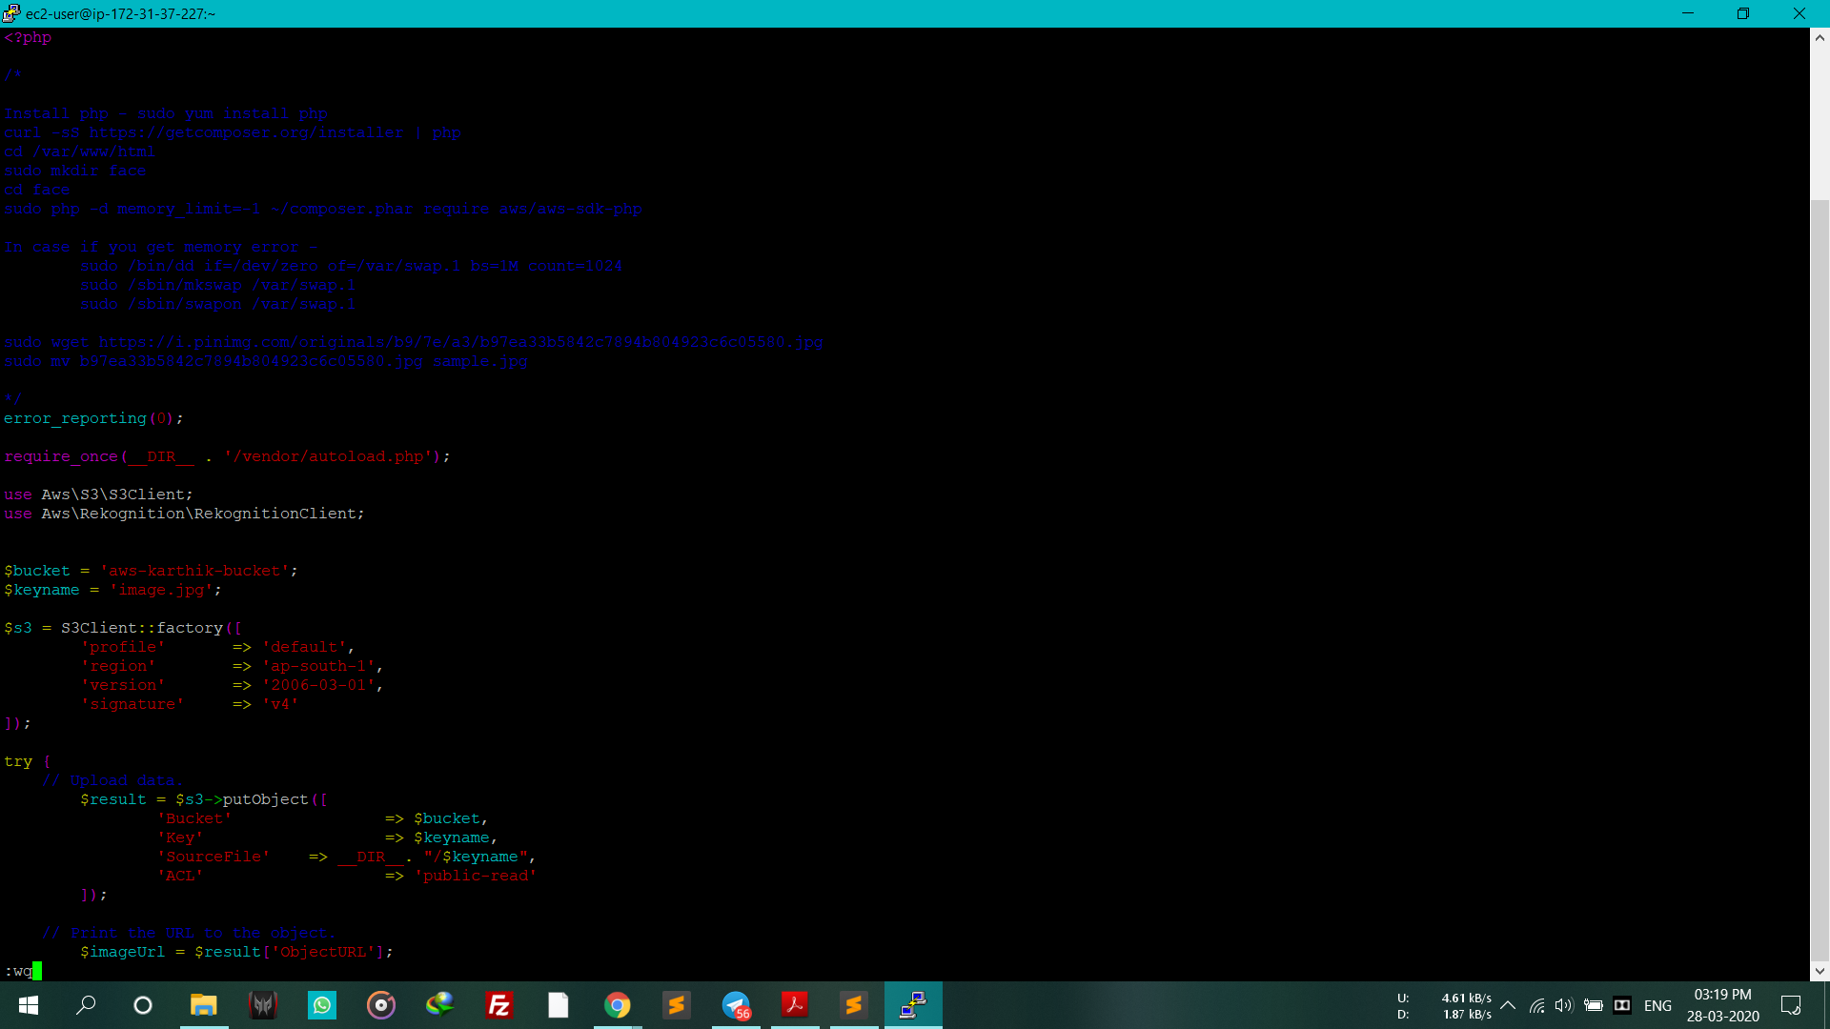

4) Upload successful message: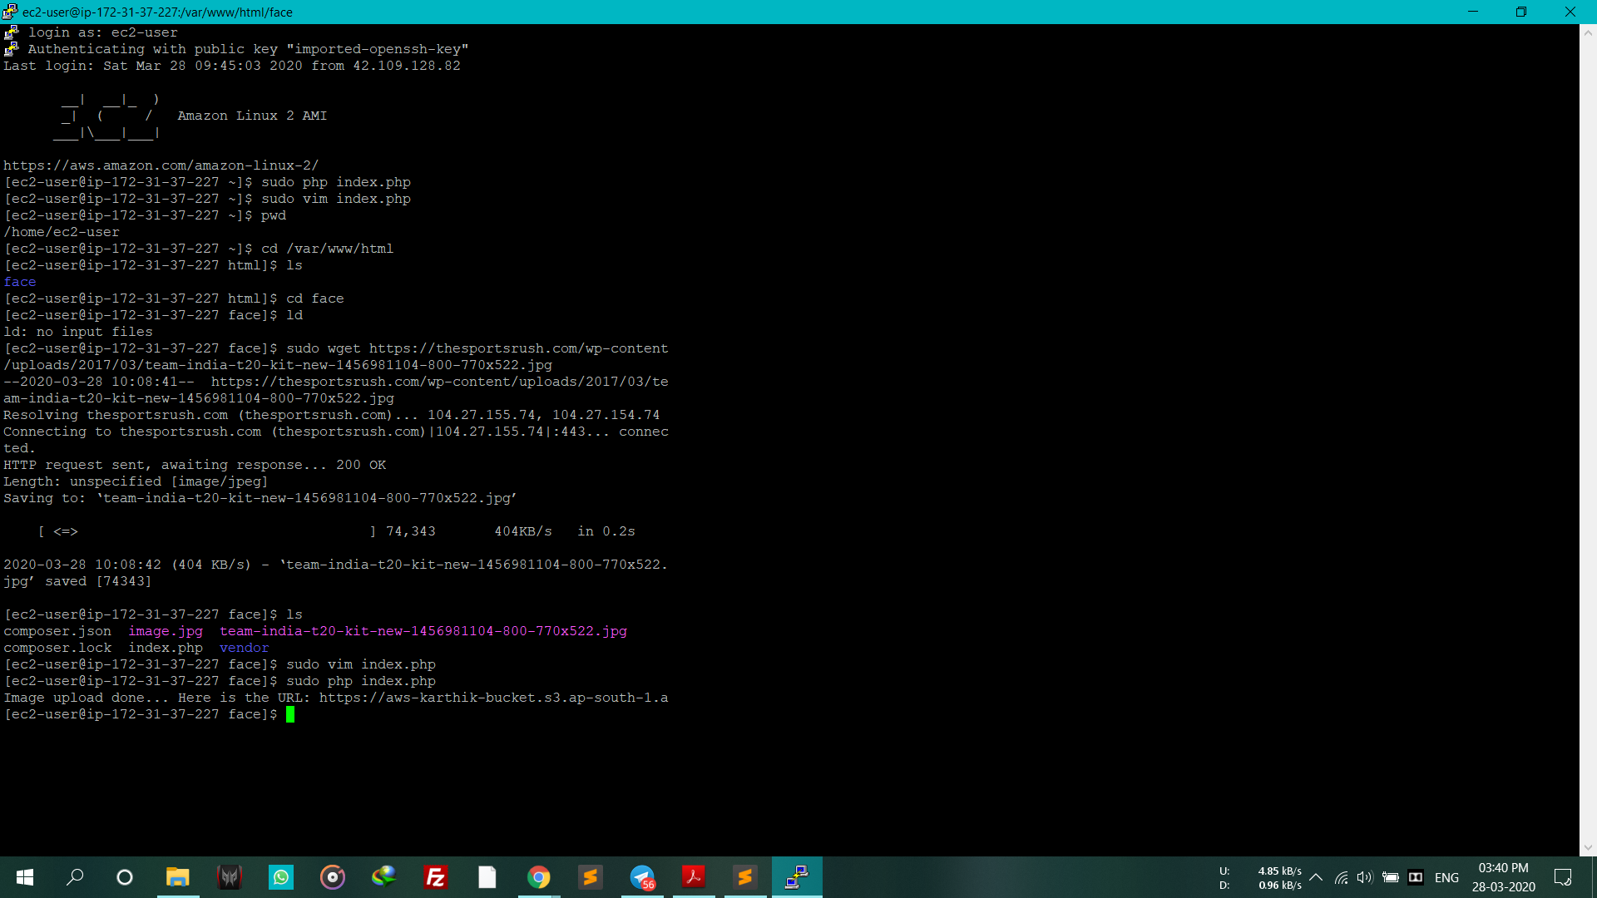

**VI) EC2 & Rekognition:**

1) Face detection successful: